OPEN HOUSE/SEMINAR
Saturday - January 28, 2006
8:00am – 9:00pm
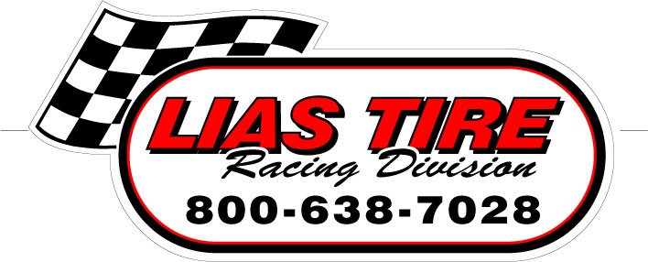

MEET AND ATTEND SEMINARS BY:

-JIM BERNHEISEL / LAZER CHASSIS 8:30-10:00am

-SCOTT & CHRIS RHODES / RHODES RACING ENGINES
ENGINE MAINTENANCE 10:30-11:00am

-BILL MARTENS(Factory Rep.) / GM CRATE ENGINES
11:00-12:00pm

-PAT MCCAULAY(Factory Rep.) / BILSTEIN SHOCKS &
-KEITH BERNER / ACCUFORCE SHOCK DYNO
2:00-4:00pm

-JIM BERNHEISEL / LAZER CHASSIS 4:30-6:00pm

- LIAS TIRE & AMERICAN RACER (Factory Reps.)
AMERICAN RACER TIRES 7:00-8:30pm

MACS SERIES AND TRACK REPS ON HAND

**SPECIAL DISCOUNTS ALL DAY**

***SHOCKS ON DYNO***
(1st 12 Reservations – 4 shocks at no charge)

COME AND TAKE ADVANTAGE OF THE TIRE PEOPLE:
FOOD & CLASS – ON THE HOUSE

SPACE IS LIMITED-RESERVATIONS ARE NECESSARY

